Prediction of Parkinson's Disease & Severity Using ML & DL Algorithms

Abstract:
Parkinson’s disease is a progressive neurological disorder that affects movement and speech. In this project, we aim to detect Parkinson’s disease using speech signals by applying both machines learning and deep learning techniques. We use a dataset containing audio speech files of healthy individuals (HC) and patients with Parkinson’s disease (PD), which include spontaneous dialogues and text reading. Features are extracted from these audio files using Python’s sound processing libraries. Initially, traditional machine learning algorithms like SVM, XGBoost, and MLP were applied, but they showed limited accuracy. To improve prediction performance, we implemented an advanced 2D Convolutional Neural Network (CNN2D), which demonstrated significantly better results. The project involves modules for uploading the dataset, Preprocessing (handling missing values and normalization), training different models, predicting on new test speech files, and comparing the performance of each model. Among all, CNN achieved the highest accuracy, even reaching up to 100%, proving to be the most effective model for detecting Parkinson’s disease from speech.

Keywords:
Parkinson’s Disease, Speech Analysis, Machine Learning, Deep Learning, SVM, XGBoost, MLP, CNN2D, Audio Feature Extraction, Disease Prediction.
2. Existing system
The existing systems for detecting Parkinson’s disease from speech data primarily rely on classical machine learning algorithms such as Support Vector Machine (SVM), XGBoost, and Multilayer Perceptron (MLP). These models depend on manually extracted audio features and basic classification logic to differentiate between healthy and Parkinson-affected speech. While they provide moderate accuracy, they often struggle to capture complex patterns and temporal variations present in real speech data. Additionally, these systems are limited in adaptability and tend to underperform on unseen or noisy samples, resulting in inconsistent and less reliable predictions across different datasets.

Draw backs:

- Low Accuracy: Traditional models like XGBoost and MLP fail to deliver high prediction accuracy for Parkinson detection from speech data.
- Poor Feature Learning: Machine learning algorithms rely on manually extracted features, missing deeper speech characteristics.
- Weak Generalization: These models perform poorly on unseen or noisy audio samples, limiting their real-world reliability.
- Limited Temporal Understanding: Classical models lack the ability to capture time-based variations present in continuous speech.
- Performance Instability: Accuracy and results vary significantly across different datasets due to lack of deep pattern recognition.

3. ⁠Propose system
The proposed system introduces an advanced deep learning-based approach for detecting Parkinson’s Disease using speech signals, addressing the limitations of traditional machine learning models. Unlike earlier methods that rely on shallow classifiers like SVM, XGBoost, and MLP, the current system employs a 2D Convolutional Neural Network (CNN2D) to capture deeper, non-linear patterns in audio data. The CNN2D model is capable of learning temporal and frequency-based speech features directly from the raw waveforms, enabling more accurate and robust classification between healthy individuals and Parkinson-affected patients. The system processes a dataset containing audio speech samples categorized into Healthy (HC) and Parkinson’s Disease (PD) classes, extracts features using Python sound processing libraries, and pre-processes the data using normalization and train-test splitting. After training and testing the CNN2D model on the processed dataset, the system demonstrates superior performance compared to SVM, XGBoost, and MLP, achieving accuracy levels of up to 100% on test data. Additionally, the application provides a user-friendly interface to upload and predict outcomes from new speech samples and visualizes comparative results through performance graphs, highlighting CNN2D as the most effective model for Parkinson’s detection from speech.

Advantages:
- High Accuracy: The CNN2D model achieves up to 100% prediction accuracy, significantly outperforming traditional machine learning algorithms.
- Automatic Feature Extraction: CNN2D automatically learns complex speech features without the need for manual feature engineering.
- Robust Performance: The model shows consistent results even with varied and noisy speech data, improving real-world applicability.
- Temporal Pattern Recognition: CNN2D effectively captures time-based variations in speech, which are crucial for detecting Parkinson’s-related impairments.
- User-Friendly Interface: The system provides easy-to-use modules for uploading, training, testing, and predicting Parkinson’s Disease from new audio files.
- Comprehensive Comparison: It includes a visual comparison of all models (SVM, XGBoost, MLP, and CNN2D), making it easy to evaluate model performance.
- Real-Time Prediction: The system can process and classify new speech inputs in real-time, allowing for immediate Parkinson’s status identification.

4. ⁠Modules
- Upload Parkinson Speech Dataset: This module allows the user to upload the entire folder of speech audio files (containing HC and PD folders). The application then reads and loads all audio files for further processing.
- Pre-process Dataset: In this step, missing values in the dataset are replaced with mean values, followed by normalization using Min-Max scaling. The data is then split into 80% training and 20% testing sets.
- Train SVM Algorithm: This module trains the Support Vector Machine (SVM) model using the pre-processed training data and evaluates its accuracy by predicting outcomes on the test data.
- Train XGBoost Algorithm: This module applies the XGBoost classification algorithm on the training data and calculates its prediction accuracy on the test dataset.
- Train MLP Algorithm: This module trains a Multilayer Perceptron (MLP) neural network on the dataset and evaluates its performance on the test data.
- Train CNN Algorithm: A deep learning module that trains a 2D Convolutional Neural Network (CNN2D) using the training data to detect Parkinson’s Disease from speech signals. It provides highly accurate predictions.
- Predict Parkinson from Test Speech: This module allows users to upload new test speech (WAV) files. It extracts features from the file and predicts whether it indicates healthy speech or Parkinson’s disease using the trained model.
- Comparison Graph: This module visualizes the performance of all trained models (SVM, XGBoost, MLP, and CNN) in terms of accuracy, precision, recall, and F1-score using a bar graph.

5. Algorithms
- SVM
- XGBOOST
- MLP
- CNN

System Architecture

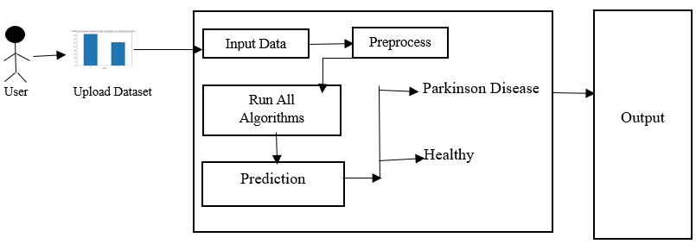

6. ⁠SOFTWARE AND HARDWARE
HARDWARE REQUIREMENTS:
Processor - Intel I3 or Above
Speed - 1.1 GHz
RAM - 4 GB (min)
Hard Disk - 500 GB (min)
SOFTWARE REQUIREMENTS:
Operating System - Windows 10 or above
Programming Language - Python 3.7.0

